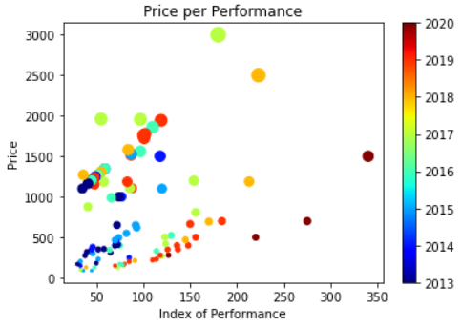

By analyzing this graph I can see an clear relationship between price performance and how it changes over the years for example if we look on the left side of the graph where most of the samples a re located we can see that as the performance incremented the price also incremented but half way to the graph we see a drop in prices where the new GPUs drop about 50% of the price range but also increasing the performance instead of decreasing it. Another thing we can see in this graph is that it is right skewed(positive skewness) which means the mode, mean and median are located at the left side of the graph where most of the samples are.

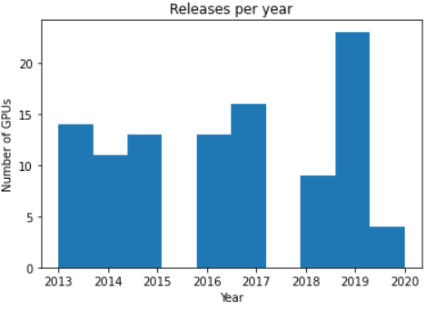

This graph displays how many GPUs were released each year, by looking at it we can see that between 2013 to 2016 the release rate is fairly equal with the exception of the gap between 2015 and 2016 which is kind of weird but the if we keep looking we see a big decrement in production in 2018 in comparison of past years and right after 2019 jumps incredibly high on release production which can mean the discovery of a new technology for GPUs or an new generation release.